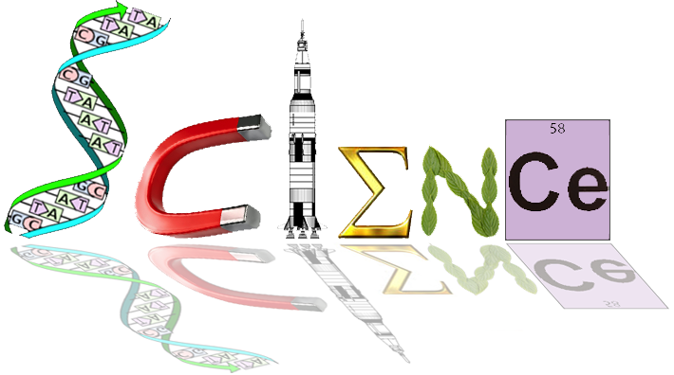

**Yr. 12 ATAR Human Biology Task 1: In Class Extended Response**

Time: 5 minutes planning – 55 minutes writing

Question

Part a. Outline an endocrine disorder or your choice, including an explanation of it cause/s, effects and symptoms, and treatments

(18 marks)

Part b. Evaluate the role of the feedback loops and/ or hormones involved in this endocrine disorder

(9 marks)

Part c. Discuss possible treatments for this disorder

(5 marks)

* Submission of A4 sheet of notes, including references

(3 marks)

**Total mark: /35**



**Yr. 12 ATAR Human Biology Task 1: In Class Extended Response**

Time: 5 minutes planning – 55 minutes writing

Question

Part a. Outline an endocrine disorder or your choice, including an explanation of it cause/s, effects and symptoms, and treatments

(18 marks)

Part b. Evaluate the role of the feedback loops and/ or hormones involved in this endocrine disorder

(9 marks)

Part c. Discuss possible treatments for this disorder

(5 marks)

* Submission of A4 sheet of notes, including references

(3 marks)

**Total mark: /35**